9. ReactJS-HOL

Create a React Application named “cricketapp” with the following components:

ListofPlayers.js
// src/components/ListofPlayers.js
import React from "react";

const players = [
{ name: "Virat Kohli", score: 95 },
{ name: "Rohit Sharma", score: 85 },
{ name: "KL Rahul", score: 40 },
{ name: "Hardik Pandya", score: 65 },
{ name: "Jasprit Bumrah", score: 75 },
{ name: "Ravindra Jadeja", score: 90 },
{ name: "Shikhar Dhawan", score: 55 },
{ name: "Rishabh Pant", score: 80 },
{ name: "Suryakumar Yadav", score: 92 },
{ name: "Mohammed Shami", score: 35 },
{ name: "Shubman Gill", score: 60 },
];

const ListofPlayers = () => {
const allPlayers = players.map((player, index) => (
<li key={index}>
{player.name} - {player.score}
</li>
));

const below70 = players
.filter((player) => player.score < 70)
.map((player, index) => (
<li key={index}>
{player.name} - {player.score}
</li>
));

return (
<div>
<h2>All Players</h2>
<ul>{allPlayers}</ul>

<h2>Players with Score &lt; 70</h2>
<ul>{below70}</ul>
</div>
);
};

export default ListofPlayers;

IndianPlayers.js

// src/components/IndianPlayers.js
import React from "react";

const T20players = ["Virat", "Rohit", "KL", "Hardik", "Bumrah"];
const RanjiTrophy = ["Sarfaraz", "Jurel", "Abhimanyu", "Saurabh"];

const IndianPlayers = () => {
const allPlayers = [...T20players, ...RanjiTrophy];

const evenPlayers = allPlayers.filter((_, i) => i % 2 === 0);
const oddPlayers = allPlayers.filter((_, i) => i % 2 !== 0);

return (
<div>
<h2>All Players (Merged)</h2>
<ul>
{allPlayers.map((player, index) => (
<li key={index}>{player}</li>
))}
</ul>

<h3>Even Team Players</h3>
<ul>
{evenPlayers.map((player, index) => (
<li key={index}>{player}</li>
))}
</ul>

<h3>Odd Team Players</h3>
<ul>
{oddPlayers.map((player, index) => (
<li key={index}>{player}</li>
))}
</ul>
</div>
);
};

export default IndianPlayers;

App.js

// src/App.js
import React from "react";
import ListofPlayers from "./components/ListofPlayers";
import IndianPlayers from "./components/IndianPlayers";

function App() {
const flag = true; // change to false to show IndianPlayers

return (
<div className="App">
<h1>Cricket App</h1>
{flag ? <ListofPlayers /> : <IndianPlayers />}
</div>
);
}

export default App;

Output

flag = true
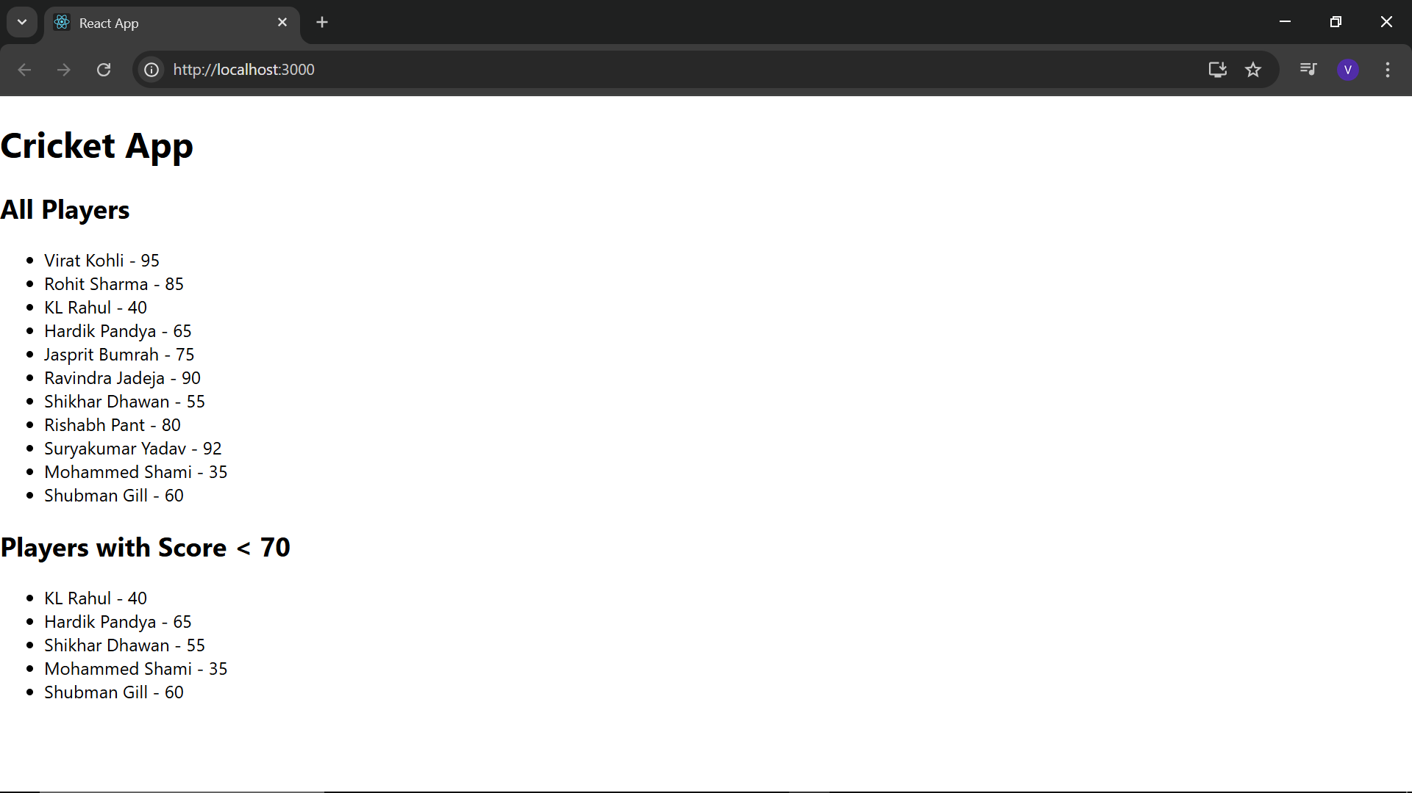flag = false
